Job-Driven Vocational Rehabilitation Technical Assistance Center

(JD-VRTAC)

The JD-VRTAC helps build the capacity of vocational rehabilitation (VR) agencies to expand job-driven employment practices for consumers. We strive to identify, adapt, embed, and sustain job-driven practices for VR agencies and their partners to provide services that lead to employment outcomes for people with disabilities by:
- Creating VR-specific, sustainable models of job-driven practices
- Promoting the use of labor market information in the counseling process
- Helping businesses find and retain qualified workers
- Using and building upon promising and emerging job-driven strategies
- Providing technical assistance (TA) to state VR agencies (see details below)
- Disseminating toolkits and materials about job-driven strategies
Technical Assistance (TA)
The JD-VRTAC provides universal, targeted, and intensive TA to state VR agencies on ways to engage and support employers and customized training providers, as well as how to understand and incorporate labor market information into VR practice.
- Universal TA: The JD-VRTAC uses ExploreVR.org as the primary portal for providing universal TA via a set of job-driven toolkits. All universal TA resources are targeted towards the three organizational levels: leadership, field services, and counselors.
- Targeted TA: The JD-VRTAC provides targeted TA through communities of practice and in-person forums. The topics for these peer-to-peer groups were identified from a nationwide needs assessment survey, issues emerging from intensive TA, and feedback from VR agencies.
- Intensive TA: Agencies receiving intensive TA were assigned a team of content experts to guide the development and implementation of their job-driven project. Intensive TA agencies have joined a learning collaborative to share strategies and solutions around these job-driven topics.
Project partners
- Jobs for the Future
- University of Arkansas CURRENTS
- University of Washington
- US Business Leadership Network
- Council of State Administrators of Vocational Rehabilitation
- Association of University Centers on Disabilities

In collaboration with
- National Council of State Agencies for the Blind
- Technical Assistance Center Collaborative
Job-Driven Toolkits
The JD-VRTAC has developed tools and resources to improve skills of VR agency staff and other rehabilitation professionals who provide job-driven VR services and supports to people with disabilities, employers, and customized training providers.

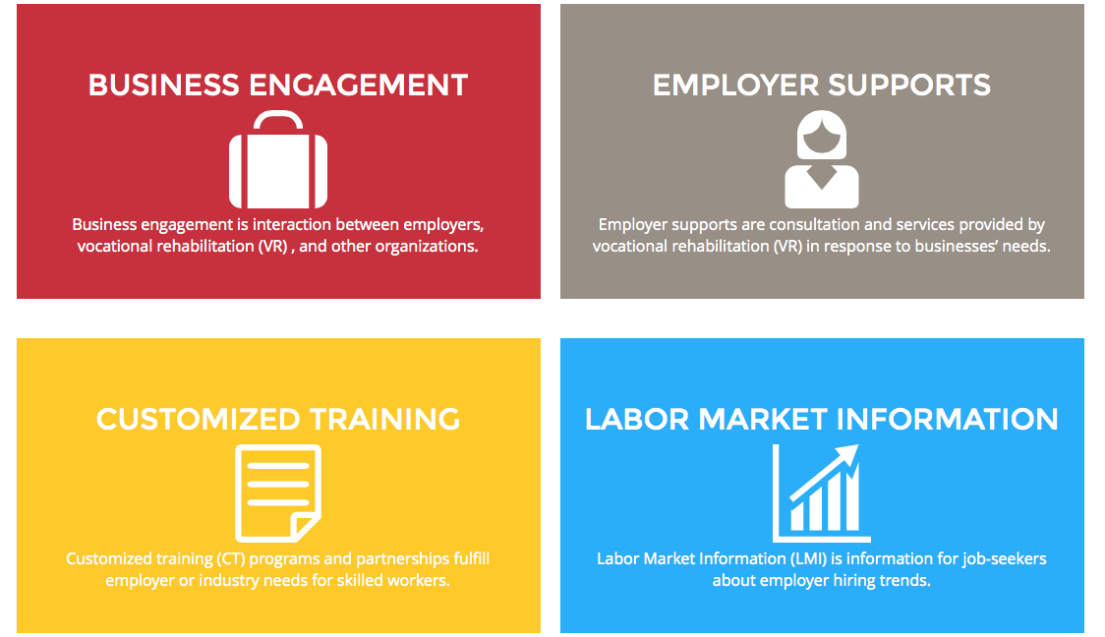
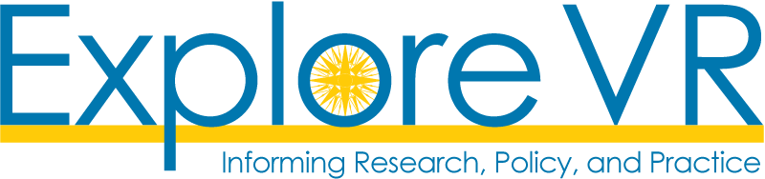
The Job-Driven VRTAC is funded by Rehabilitation Services Administration Grant (RSA) #H264A140002.

